A Sleep Tracking App For A Better Night's Rest

1.INTRODUCTION:

Overview:

A project that demonstrates the use of Android Jetpack Compose to build a UI for a sleep tracking app. The app allows users to track their sleep. With the “Sleep Tracker” app, you can assess the quality of sleep they have had in a day. It has been time and again proven that a good quality sleep is pretty essential for effective functioning of both mind and body.

“Sleep Tracker” application enables you to start the timer when they are in the bed and about to fall asleep. The timer will keep running in the background until it is stopped, whenever the user wakes up. Based on the sleep experience, you can rate your sleep quality. Finally , the app will display an analysis of the kind of sleep , you had the previous night.

PURPOSE:

• You’ll be able to work on Android studio and build an app.

• You’ll be able to integrate the database accordingly.

EMPATHY MAP:

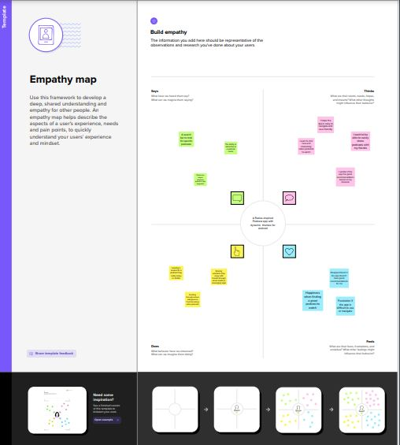

IDEATION & BRAINSTORMING MAP:

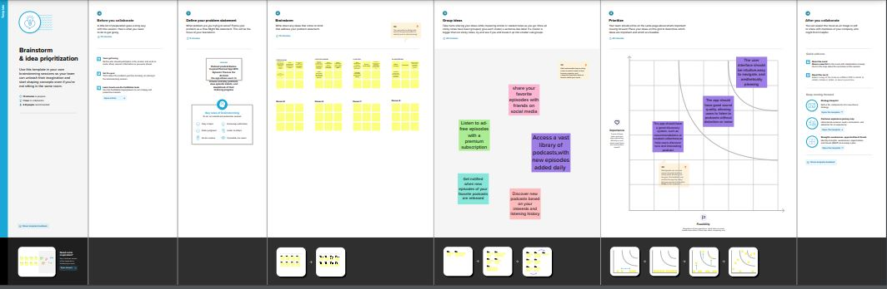

3.RESULT:

## C:\Users\STUDENT\Downloads\sleep tracking app\S.jpgC:\Users\STUDENT\Downloads\sleep tracking app\M.jpg C:\Users\STUDENT\Downloads\sleep tracking app\N.jpg C:\Users\STUDENT\Downloads\sleep tracking app\B.jpg

4.ADVANTAGE & DISADVANTAGE:

. Helps improve your sleep quality

While monitoring your sleep, some sleep trackers can break down the different sleep stages you work through and also any movement. Then, in the app you're given insights on your experience and also helpful coaching to help make changes to achieve your sleep goals.

* Sleep trackers introduce poor sleep hygiene. ...
* Sleep trackers may be inaccurate. ...
* Sleep trackers can worsen insomnia. ...
* Sleep trackers make some people resistant to treatment. ...
* Sleep trackers are tied to a sleep disorder.

5.APPLICATION:

1.sleep tracking

2. Prime nap is a free sleep tracker that will track your sleep and provide you with useful data and charts that analyze your sleep length and quality.

3. it records your sleep based on movement and can be used for nighttime sleep and mid-day naps.

6.CONCLUSION:

Apps available for sleep self-management and tracking may be valuable tools for self-management of sleep disorder and/or improving sleep quality, yet they require improvement in terms of quality and content, highlighting the need for further validity studies.

7.FUTURE SCOPE :

* **Measuring sleep brain wave activity:**

which can show doctors how quickly you fall asleep, how deeply you sleep and whether rest quality is good

* **Assessing leg movements:**

To detect restless legs syndrome

* **Monitoring breathing:**

 To help diagnose sleep apnea. In addition, home monitoring captures how well you rest in the comfort of your own home. Sleeping in a lab does not give doctors or researchers an idea of what a typical night’s sleep is like for you in your bedroom or sleep environment.

8.APPENDIX:

